Issue Tracker
Objective:
Issue Tracker is an online application to be built as a product that provide Issue tracking for projects.
Users of the System:
- Admin
- Developers
- Guest
Functional Requirements:
- Individual accounts for Developers.
- Ticket creation and updation.
- Assigning or UN-assigning a ticket to Developer by higher authorities or by themselves.
- Uploading patch files or any other required files after solving the issue and update the ticket status
- Export a ticket in different formats like doc and pdf.

While the above ones are the basic functional features expected, the below ones can be nice to have add-on features:
- Watch service for subscribing a ticket.
- Vote for ticket.
- Share ticket through mail

Output/ Post Condition:
- Daily Tickets Reports
- Daily Solved tickets Reports
- Monthly Tickets Reports

Non-Functional Requirements:

Security | - App Platform –UserName/Password-Based Credentials  - Sensitive data has to be categorized and stored in a secure manner  - Secure connection for transmission of any data
Performance | - Peak Load Performance  - Issue Tracker -< 3 Sec  - Admin application < 2 Sec  - Non Peak Load Performance
Availability | - 99.99 % Availability
Standard Features | - Scalability  - Maintainability  - Usability  - Availability  - Failover
Logging & Auditing | - The system should support logging(app/web/DB) & auditing at all levels
Monitoring | - Should be able to monitor via as-is enterprise monitoring tools
Cloud | - The Solution should be made Cloud-ready and should have a minimum impact when moving away to Cloud infrastructure
Browser Compatible | - IE 7+  - Mozilla Firefox Latest – 15  - Google Chrome Latest – 20  - Mobile Ready

Technology Stack
Front End | React 16+  Google Material Design  Bootstrap / Bulma
Server Side | Spring Boot  Spring Web (Rest Controller)  Spring Security  Spring AOP  Spring Hibernate
Core Platform | OpenJDK 11
Database | MySQL or H2

Platform Pre-requisites (Do’s and Don’ts):
- The React app should run in port 8081.
- Spring boot app should run in port 8080.

Key points to remember:
- The id (for frontend) and attributes(backend) mentioned in the SRS should not be modified at any cost. Failing to do may fail test cases.
- Remember to check the screenshots provided with the SRS. Strictly adhere to id mapping and attribute mapping. Failing to do may fail test cases.
- Strictly adhere to the proper project scaffolding (Folder structure), coding conventions, method definitions and return types.
- Adhere strictly to the endpoints given below.

Application assumptions:
- The login page should be the first page rendered when the application loads.
- Manual routing should be restricted by using AuthGaurd by implementing the canActivate interface. For example, if the user enters as http://localhost:4200/signup or http://localhost:4200/home the page should not navigate to the corresponding page instead it should redirect to the login page.
- Unless logged into the system, the user cannot navigate to any other pages.
- Logging out must again redirect to the login page.
- To navigate to the admin side, you can store a user type as admin in the database with a username and password as admin.
- Use admin/admin as the username and password to navigate to the admin dashboard.

Validations:
- Basic email validation should be performed.
- Basic mobile validation should be performed.
Project Tasks:
API Endpoints:
USER
Action | URL | Method | Response
Login | /login | POST | true/false
Add Issue | /addIssue | POST | Issue added
List logged in user issue | /issue/{id} | GET | Array of Issue
Update Issue | /issue/{id} | PUT | Issue Updated.
Update Status | /status/{id} | PUT | Status Updated.
ADMIN
Action | URL | Method | Response
Get All Issue | /admin | GET | Array of Issue
Add Developers | /admin/addDevelopers | POST | Developer added
Update Developer | /admin/updateDeveloper/{id} | PUT | Developer Updated
Delete Developer | /admin/deleteDeveloper/{id} | DELETE | Delete Successful
Map Issue | /admin/mapIssue/{issueId} | POST | Save the Changes
Get All Opened Status | /admin/openStatus | GET | Array of Status
Get All Closed Status | /admin/closedStatus | GET | Array of Status

Frontend:
User:
Login:
Output Screenshot:
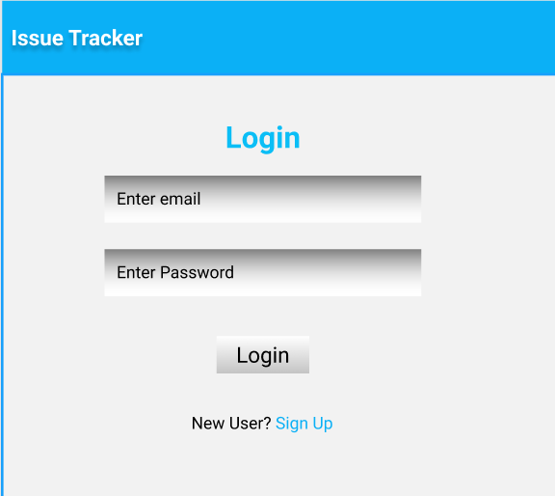

Signup:
Output Screenshot:
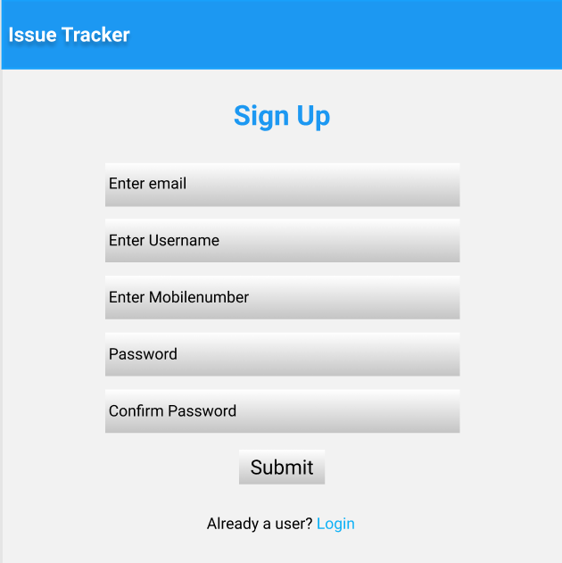

Home:
Output Screenshot:
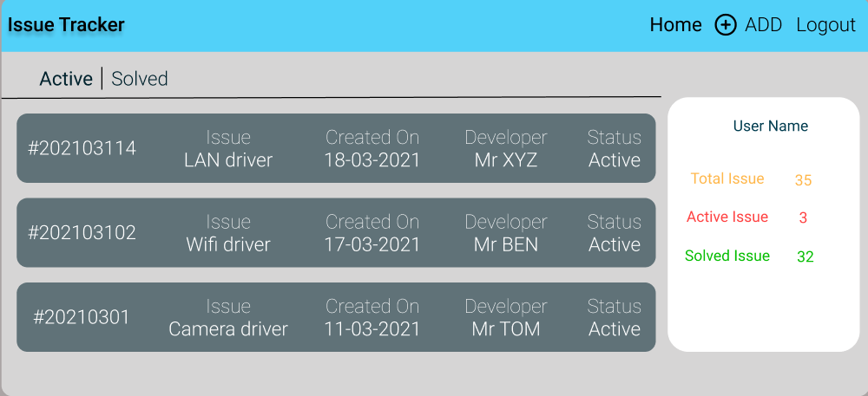

Add Issue:
Output Screenshot:
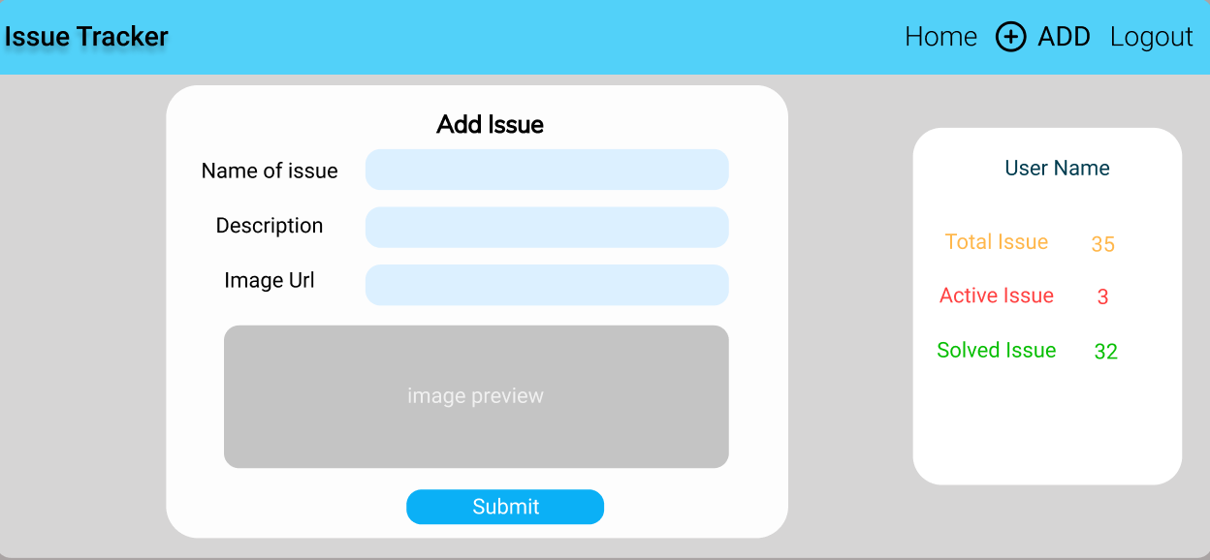

Developer:
Home:
Output Screenshot:
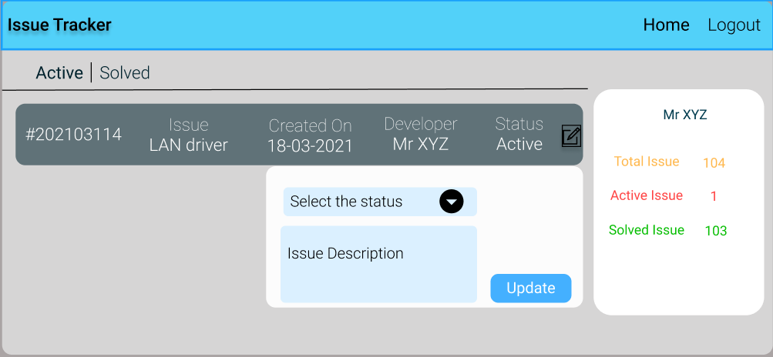

Admin:
Home:
Output Screenshot:
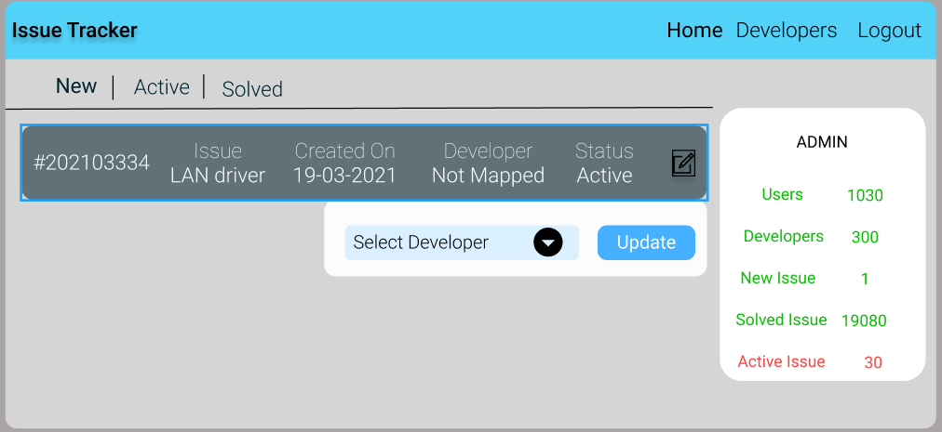

Admin Developers:
Output Screenshot
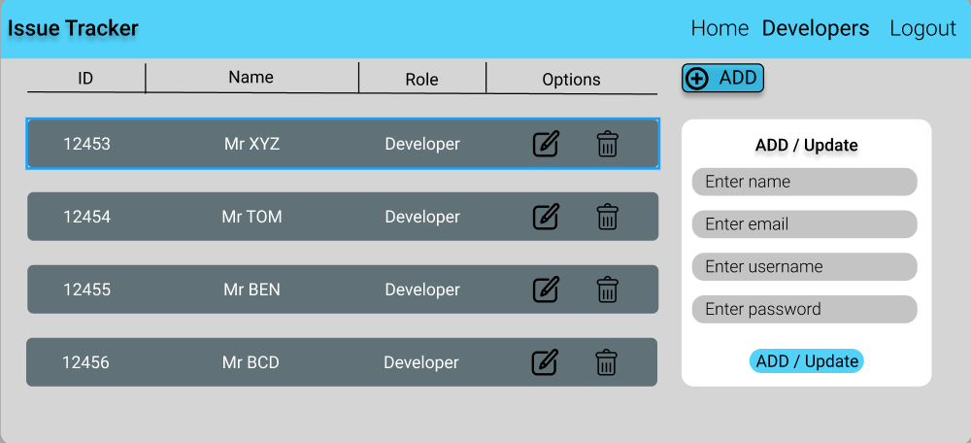

Backend:
Class and Method description:

Model Layer:

- UserModel: This class stores the user type (admin or the customer) and all user information.
  - Attributes:
    - email: String
    - password: String
    - username: String
    - mobileNumber: String
    - active: Boolean
    - role: String
  - Methods: -

- LoginModel: This class contains the email and password of the user.
  - Attributes:
    - email: String
    - password: String
  - Methods: -

- IssueModel: This class stores the details of the Issue.
  - Attributes:
    - issueId: String
    - imageUrl: String
    - issueName: String
    - issueDesc: String
    - createdOn: Date
    - createdBy: UserModel
    - connectedBy: UserModel
    - status: String
  - Methods: -
- StatusModel: This is hold the Status of all the Issues.
a. Attributes:
- issueId: String
- statusId: String
- status: String
- statusDesc: Desc
b. Methods: -
Controller Layer:
- UserController: This calss controls the add/edit/update/view the users.
  - Attributes: -
  - Methods:
    - List<userModel> getUsers(): This method helps the admin to fetch all users from the database.
    - UserModel userDataById(String id): This method helps the admin to retrieve a user from the database based on the user id.
    - userEditSave(UserModel data): This method helps the admin to edit a user and save it to the database.
    - userSave(UserModel data): This method helps the admin to add a new user to the database.
    - UserDelete(UserDelete String id): This method helps the admin to delete a user from the database.
- LoginController: This class controls the user login.
  - Attributes: -
  - Methods:
    - checkUser(LoginModel data): This method helps the user to sign up for the application and must return true or false
- IssueController: This class controls the add/edit/update/view Issue.
  - Attributes: -
  - Methods:
    - List<IssueModel> getIssue(): This method helps the admin to fetch all Issue from the database.
    - List<IssueModel> getHomeIssue(): This method helps to retrieve all the Issue from the database.
    - IssueModel IssueEditData(String id): This method helps to retrieve a Issue from the database based on the Issue Id.
    - IssueEditSave(IssueModel data): This method helps to edit a Issue and save it to the database.
    - IssueSave(IssueModel data): This method helps to add a new Issue to the database.
    - IssueDelete (String id): This method helps to delete a Issue from the database.
- StatusController: This class helps to manage the open / closed issues.
  - Attributes: -
  - Methods:
    - mapIssue(String issueId, String StatusId): This method helps the map the issue with status.
    - List<StatusModel> showOpenStaus(): This method helps to view the all opened status
    - List<StatusModel> showClosedStaus(): This method helps to view the all Closed status.
    - updateStatus(String id): This method helps to update the status of the

